**Practical Task 1**

**JOB SEEKERS**

Task: Find 5 junior tech roles currently being advertised. (…) For each of the roles you have identified, identify the recruiting or hiring managers and their contact details.

**Role 1 - Large company (1000+ employees)**

* URL: <https://careereu.infotreeglobal.com/jobs/3407524-data-scientist-ml-ai>
* Role: Data Scientist ML/AI
* Company name: Infotree Global Solutions
* Size: 1,001-5,000 employees
* Recruiter or Contact Name
  + Name: Justyna Kasperowicz
  + LinkedIn: <https://www.linkedin.com/in/justyna-kasperowicz-55277661/>
  + E-mail: [justyna.kasperowicz@infotreeglobal.com](mailto:justyna.kasperowicz@infotreeglobal.com)

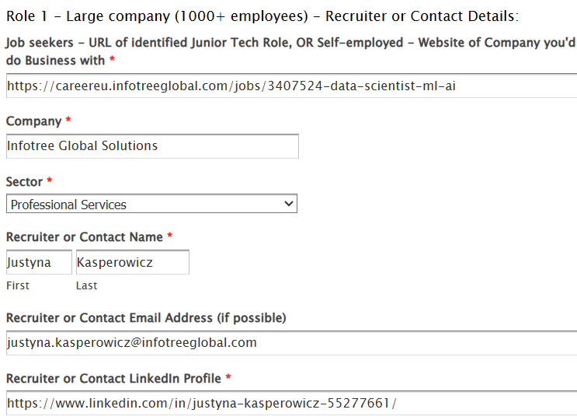

**Role 2 - Small Company (500-1000 employees)**

* URL: <https://www.cognism.com/jobs?gh_jid=4261932101>
* Role: Data Scientist
* Company name: Cognism
* Size: 501-1,000 employees
* Recruiter or Contact Name
  + Name: Richard Fye
  + LinkedIn: <https://www.linkedin.com/in/richardfye/>
  + E-mail: [recruitment.group@cognism.com](mailto:recruitment.group@cognism.com)

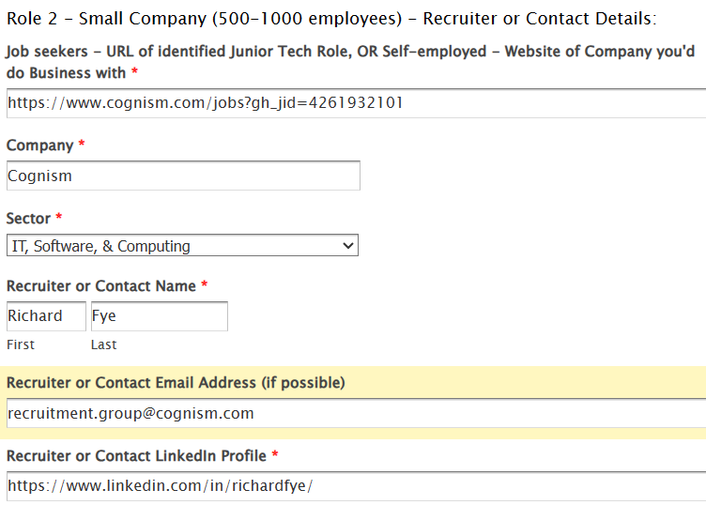

**Role 3 - Tech Scale-up (up to 100 employees)**

* URL: <https://www.tdi-sustainability.com/vacancies/marketing-communications-intern/>
* Role: Data Analyst
* Company name: TDi Sustainability
* Size: 11-50 employees
* Recruiter or Contact Name
  + Name: Hayley Flack
  + LinkedIn: <https://www.linkedin.com/in/hayley-flack-558ab4a6/>
  + E-mail: [info@tdi-sustainability.com](mailto:info@tdi-sustainability.com)

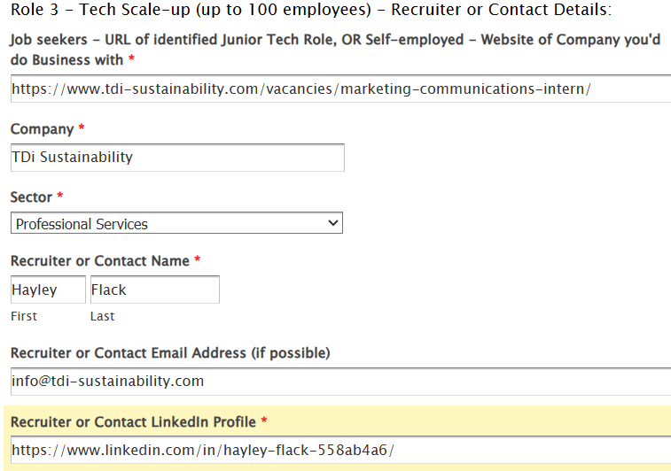

**Role 4 - Paid internship or Apprenticeship**

* URL: <https://apply.workable.com/bmlltech/j/E9528CDC70/>
* Role: INTERNSHIP - Junior Quantitative Analyst
* Company name: BMLL
* Size: 51-200 employees
* Recruiter or Contact Name
  + Name: Humaira Khalid
  + LinkedIn: <https://www.linkedin.com/in/humaira-khalid-b7a365b5/>
  + E-mail: [bmlltech@jobs.workablemail.com](mailto:bmlltech@jobs.workablemail.com)

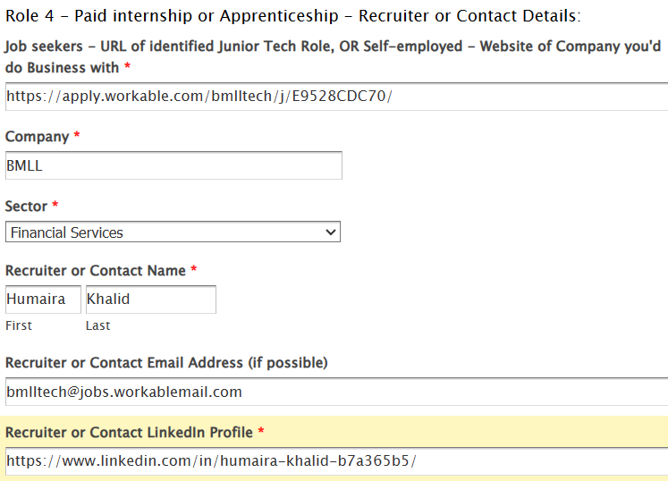

**Role 5 - Hire-to-Train, Recruitment Agency Role, or Any Other Company**

* **Type: Freelance**
* URL: [https://jobs.telusinternational.com/en_US/careers/PipelineDetail/Online-Data-Analyst-United-Kingdom/21429?source=LinkedIn#](https://jobs.telusinternational.com/en_US/careers/PipelineDetail/Online-Data-Analyst-United-Kingdom/21429?source=LinkedIn)
* Role: Online Data Analyst - United Kingdom
* Company name: TELUS International
* Size: 10,001+ employees
* Recruiter or Contact Name:
  + Name: Henry Regan - Rushe
  + LinkedIn: <https://www.linkedin.com/in/henry-regan-rushe-9722b4146/>

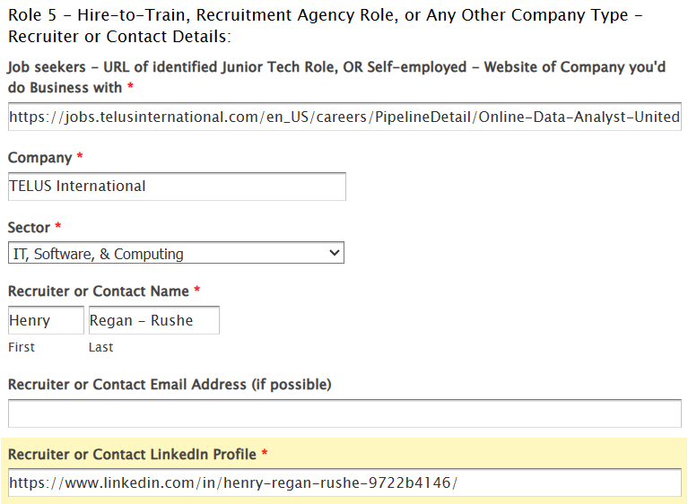

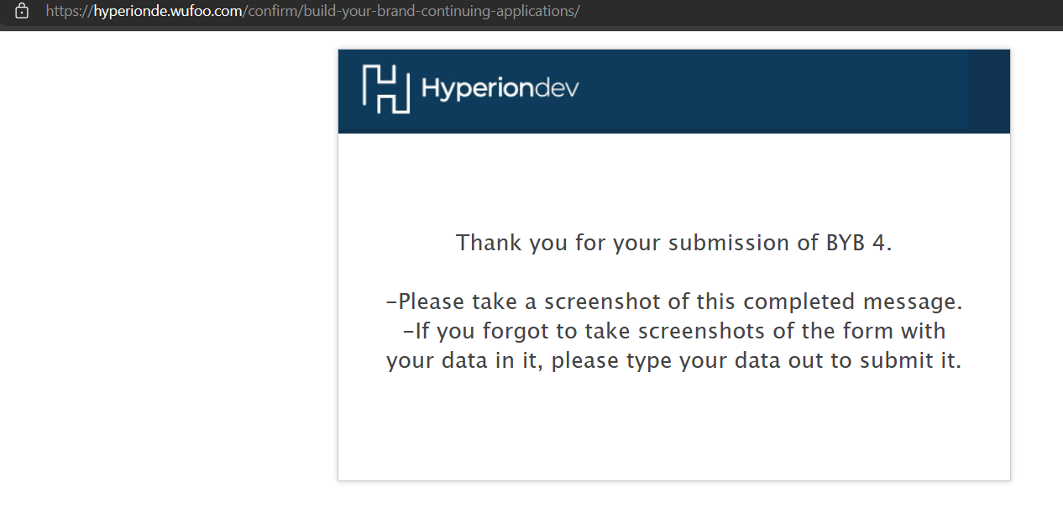

**My public link to Job Interviews tracker:** <https://docs.google.com/spreadsheets/d/1gEFmy1UcSykVU2mKGeZj2-488Q82bpgensGVNrbzPsE/edit?usp=sharing>

I have a new one as the old one got deleted for some reason ☹ -> (<https://docs.google.com/spreadsheets/d/12TX9iYbzYEnn4uMH0XC7RVWj6YGCPJVm0QRKc4j-L4I/edit?usp=sharing> )

**Practical Task 2**

Task: Using one of the job listings you identified in Practical Task 1, prepare for an interview at the company by writing answers to these common interview questions.

* **Chosen job listing: INTERNSHIP - Junior Quantitative Analyst at BMLL**
* **URL:** [**https://apply.workable.com/bmlltech/j/E9528CDC70/**](https://apply.workable.com/bmlltech/j/E9528CDC70/)

1. Copy the job description

## Description

**About Us**

We are a historical data and analytics company, solving some of the most complex and challenging problems in big data and financial markets. We have built an award-winning data science platform for processing vast quantities of granular limit order book data, and have a series of products built on this platform.

We have a fantastic team and our culture is inclusive and highly collaborative - a place where our employees are encouraged to be themselves.

We give all our employees share options, empowering them to get involved in decision making and help shape the future of our company as we continue to grow and scale.

We offer a combination of remote and office (London based) working, weekly team lunches and plenty of office snacks!

For more information, please visit our website, [**www.bmlltech.com**](http://www.bmlltech.com/) or visit our Twitter, @bmlltech or LinkedIn, @BMLL.

**About the role**

We are looking for a highly motivated Junior Quantitative Analyst intern to join our product team. The Quantitative Analyst Intern will utilise our products to develop marketing and analysis, as well as working with our customers to gather feedback and help them use the product suite. You will have the opportunity to work on exciting projects, collaborate with industry experts, and contribute to the success of our clients.

**What makes this job special:**

* This is a mixture of data science, sales, and marketing. All your work will have a direct impact on the business.
* You will have access to a petabyte scale data lake and an award-winning data science environment to analyse the data.

**As a Junior Quantitative Analyst Intern, you will:**

* Utilise the BMLL product suite to support marketing and sales to help sell the BMLL product suite.
* Work closely with the go-to-market team to evangelise the product, support our customers and gather feedback to help shape product requirements.
* Help with technical prototyping for external partners and clients.
* Support the product team in the development and management of the product roadmap, idea generation and product development cycle.

## Requirements

**Essential:**

* Experience of python for the purposes of data science, and familiarity with data science tools (Jupyter, pandas, Plotly)
* Willingness to work in a fast-paced environment, with an ability to do quick analysis to a tight deadline
* Excellent teamwork and ability to work in multidisciplinary team
* Basic knowledge of financial markets and trading concepts
* Ability to work effectively, both independently and as part of a team
* Strong presentation and communication skills

**Desirable:**

* **Experience with SQL scripting and querying**
* **Knowledge and interest in statistics and machine learning and their applications to finance**

2. Describe the company and its product in a short paragraph, explaining why you would be a good fit (150-200 words).

BMLL, established in 2014, is a London-based data science company with a team size ranging from 51 to 200 employees. Their flagship product, *Level 3 Data* software, offers a cloud-native managed service tailored for AI/ML-driven analytics, catering to financial market modelling. Clientele spans across banks, brokers, asset managers, global exchange groups, hedge funds, and more.

I am confident that I am an excellent fit for this position because:

* I have six years of Python experience for data science and proficiency in tools like Jupyter, Pandas, and Plotly.
* My Ph.D. degree in Physics from the University of Cambridge has prepared me for fast-paced environments and tight deadlines.
* As an extroverted team player, I excel at fostering collaboration in multidisciplinary settings.
* I possess a strong interest in financial markets and trading concepts.
* With a decade-long research tenure at top universities, recognized through many awards, I can work effectively both independently and as part of a team.
* I have demonstrated presentation and communication skills through accolades for best conference presentations.
* I am proficient in SQL scripting from a previous software development role.
* Additionally, I have expertise in statistical courses and hardware for AI acquired during my Physics degree.

3. Outline your background and what appeals to you in the job description.

My background

In January, I completed my Ph.D. in Physics at the *University of Cambridge*. As a pioneer in hardware development for Artificial Intelligence, I have contributed to research highlighted in a highly-cited paper published in [*Nature*](https://www.nature.com/articles/s41586-020-2038-x). Additionally, I am nearing completion of a Data Science Bootcamp to master my programming abilities, although I have been using *Python* daily for five years. Beginning March 1st, I embarked on a traineeship at the *European Commission*, where I will apply my data science expertise to the development of the twin model of earth (<https://destination-earth.eu/>). Currently seeking a job position to commence after my internship concludes in July.

I am drawn to this job offer for several reasons:

* First and foremost, I am enthusiastic about learning from the distinguished researchers at BMLL.
* I have acquainted myself with the *Level 3 Data* software and am thoroughly impressed by its capabilities. I am eager to contribute to and be a part of it.
* I appreciate the company's size.
* I aspire to build a career in finance.
* I am keen on furthering my involvement in AI development.
* The opportunity for a blend of remote and office work aligns with my preferences.
* I meet all the requirements outlined for the position.
* As it is a temporary internship, it allows me to evaluate whether the company is a good fit before committing fully.

4. Describe a time when you made a mistake and identify a lesson you learned from this incident. (Hint: use the STAR technique).

* **Situation**: Upon deciding to pursue my PhD at the *University of Cambridge* in the *DiMartino Lab*, I found myself as the inaugural member aside from my supervisor. Consequently, I lacked the presence of fellow lab mates for daily assistance and learning opportunities, which made the pursuit of my degree very difficult.
* **Task**: My duties included creating a new research laboratory from scratch. This entailed developing the entire software infrastructure, encompassing communication with hardware and scripts for data analysis. Furthermore, as new members joined, I assumed the role of the most experienced individual, necessitating my involvement in their training, consuming a lot of my scarce time.
* **Action**: Diligently, I devoted myself to the task, constructing essential Python libraries and codes with guidance from open-source resources such as *Google, YouTube*, and *Stack Overflow*. Following the training of seven new members, I communicated to my supervisor the necessity for those I had previously trained to assume responsibility for onboarding newcomers henceforth. This afforded me valuable time to further master the lab infrastructure.
* **Result**: Through my efforts, I successfully established an opto-electrical lab, leveraging *Python* to automate measurements and analyse data, as evidenced in [the resulting scientific paper](https://onlinelibrary.wiley.com/doi/full/10.1002/adma.202209968). Furthermore, I discovered my affinity for coding, prompting me to pivot my career path towards becoming a data scientist.